OFFICIAL USE ONLY
Paid
Method
Brightlime
Initials
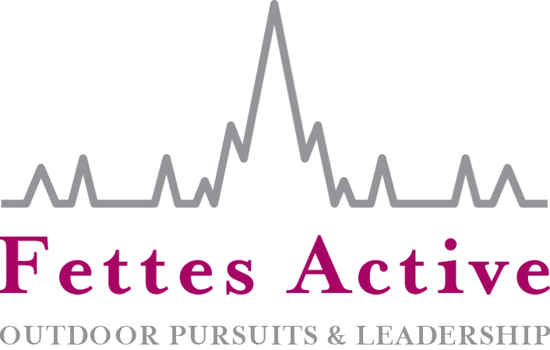

APPLICATION FORM

summer (8th to 12th AUGUST 2022)
Boys & girls aged 12-16
How did you hear about the Fettes Active Outdoor Pursuits and Leadership Camp?
What does your child hope to achieve during this camp?
Child’s details
First name
Preferred name
Surname
Date of birth
Gender
Age at time of camp
Address

Postcode
School attending

Full name of parent/carer
Home telephone
Mobile
Email

Please provide emergency contact details of a person other than the named parent/carer
Name
Relation to child
Home telephone
Mobile
How will your child arrive at and depart from the camp each day? Please delete as appropriate.
(Someone will drop them off and pick them up / They will arrive and depart on their own)
Notes
Please provide the name and contact number of any person who will bring or collect the child to/from the Fettes Active Outdoor Pursuits and Leadership Camp not already mentioned on this form.
Name ________________________________________ Contact number
I give permission for the named contacts on this form to collect the named child on my behalf.
Parent/carer signature ___________________________ Date
Medical Details
Doctor’s name
Doctor’s address
Doctor’s telephone
Additional Information
Please provide information regarding any known medical conditions (e.g. allergies/asthma) or additional support needs (e.g. dyslexia/ADHD/anxiety/autism) that will help our staff deliver the best experience for your child. Please also state any medication your child is currently taking.

dietary requirements
As we will be cooking at least once on the camp, please provide information about any dietary requirements your child may have (e.g. vegetarian, vegan, food allergies)

Medical Authorisation
As parent/carer, I hereby give permission in my absence and only in an emergency for the Fettes Active Outdoor Pursuits and Leadership Camp staff to authorise any necessary medical treatment required for my child.
Name Relationship to child
Signature Date
Child - 12 Years old and above consent
If you are 12 years old or above, we require your consent for the use of images and videos taken of you during the Fettes Active Outdoor Pursuits and Leadership Camp to be used for marketing and advertising purposes. For example, brochures, blogs, websites, social media and presentations.
Please tick one of the boxes below.
I give consent
I do not give consent

Name _ ___________________________________
Signature ___________ _____________________ Date _______________________________

